**Specialize Behavior With Inheritance**

|  |  |  |
| --- | --- | --- |
| *a class its source has become complicated due to an ad hoc implementation of a secondary responsibility* |  | *isolate the secondary responsibility from the original class and have it implemented by subclassing* |

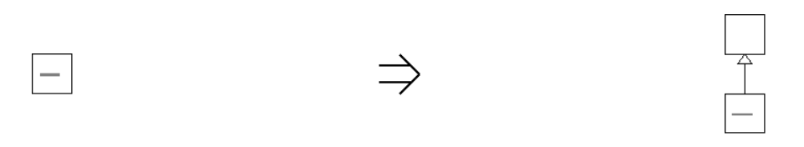

**Context:**

[Specialize Behavior With Inheritance](https://web.archive.org/web/20090914101230/http:/www.refactoring.be/thumbnails/rtn-sbwi.html) separates the secondary responsibility from the superclass but keeps the superclass responsible for interfacing to its client classes. [Replace Concrete Interfacing Class With Explicit Interface](https://web.archive.org/web/20090914101230/http:/www.refactoring.be/thumbnails/rtn-rcicwei.html) continues this refactoring.

See also :[Push Down Feature](https://web.archive.org/web/20090914101230/http:/www.refactoring.be/thumbnails/rtn-pdf.html)